

Quanta Fellowship Application Project
Congratulations on being selected as a finalist for the Quanta QR Fellowship! We’ve had thousands of impressive applicants, including chess grandmasters, Math and Physics Olympiad Medalists, Top 100 on the Putnam, PhDs from MIT, Harvard, Caltech… the list goes on. We have chosen fewer than 5% of applicants to complete this take-home project. We will choose the fellows based on your performance on this project.
Deadline: The deadline for your final submission is Midnight on December 21, 2025. If you need more time than that, you must let us know ASAP.
Objective: Your Goal is to develop a robust portfolio of signals for QQQ that, when combined in a rigorous way, achieves a Sharpe Ratio of 2.0+ in the Holdout Blind Out of Sample (or gets as close as possible!) and performs strongly across 8 hidden 3-month periods across a variety of regimes.
Tips to Maximize Your Success: You can submit as many iterations as you want, as quickly and as often as you want and our team will give you feedback and suggestions within 24 hours of each draft submission on how you can improve it. This is HIGHLY encouraged and will maximize your chances because we can help guide you and give you an indication of how well you are doing compared with other candidates and the expected results. If you only do one submission at the end, you won’t get any opportunities to improve, iterate or see where you’re standing.
Fellowship Details: The official fellowship will begin from January through February. It is remote with regular weekly Zoom check-ins with our team. You will learn to create a full, institutional-grade strategy with a 2.0+ Sharpe (that looks amazing on resumes for Quant jobs). Fellows will be prioritized for full-time and intern roles at Quanta (we hire for both throughout the entire year). Fellows will receive a $1500 award at the end of successfully completing the fellowship.

The LLM Alpha Discovery Challenge
Leveraging Next-Gen AI for Signal Generation
Quantitative finance is evolving. We are moving beyond standard technical analysis and into the era of LLM-assisted hypothesis generation. This challenge asks you to stop treating AI as just a coding assistant and start treating it as a quantitative research partner. Your goal is to use Gemini 3.0 (via Google AI Studio) to brainstorm, code, and validate 30+ trading signals based on different orthogonal ideas from technicals to volume, to cross asset patterns, and more. Then use Gemini to help combine together to create a portfolio with out-of-sample performance, aiming for a minimum 2.0 Sharpe. We are looking for creativity—unconventional logic, alternative data correlations, or novel combinations of traditional factors—that result in a mathematically robust edge.
The Mission & How You’ll be Assessed:
Develop a portfolio of signals that, when combined in a rigorous way, achieves a Sharpe Ratio of 2.0+ in the Holdout Blind Out of Sample (or gets as close as possible!).
You will be assessed on a variety of factors including:
- Your strategy performance out of sample
- Your strategy performance across 8 hidden 3-month periods across different regimes from 2000 through 2025 (regimes can be a variety of different market conditions, including but not limited to volatility, bear and bull markets, flat periods, and whipsaw periods)
- The robustness of your signals/overall strategy (do they make sense? How do they handle sensitivity testing)
- Your creativity (using unique datasets or ideas that others don’t use), and
- Your proven ability to iterate and learn. Prove that you can quickly become one of the best in the world at using LLMs to build signals and strategies. The best way to accomplish this is to send us your progress as you go, asking for feedback.

TIP: Gemini is going to push you to only have 5 or so total signals. Don’t let it… push it hard, iterate a lot and get 50+ signals (ideally uncorrelated) and then start to combine them. Again, gemini might try to combine only 5 so tell it to use 15 or 20 or more to really get great performance. Shoot for 5+ signals per main signal type, then get some speciality signals to fill holes (like short only signals even if they don’t have great individual performance), then combine them at the end.

Constraints & Objectives:
- You must use Gemini 3.0 with Code Execution Enabled (bottom right of the screen- it is NOT turned on by default, so you have to turn it on whenever you start a new prompt thread) to ensure that every hypothesis is immediately backtested and verified for accuracy within the chat interface.
- You must also give Gemini 3.0 the dataset(s) to use, build signals from, and backtest. If you do not give it the data, it will hallucinate, and it will be wrong. The data to use on QQQ is below.
- TRAIN: You must train your signals using only data from 1/1/2000 through 12/31/2015
- VALIDATE: You must test your signals on the validation test period of 1/1/2016 through 12/31/2021
- You shouldn’t develop new signals on validation 1/1/2016 through 12/31/2021, but you can tune your signals and use it for model selection and looking at combined signal performance.
- The Blind Holdout Period is 1/1/2022 - 6/30/2025. Never iterate using this period.
- You should only look at the Blind Holdout Out of Sample performance after you’ve completed signal development and your overall model. *Never* iterate using the blind out-of-sample period. If you see that your model doesn’t perform well enough in the blind out of sample, do a post mortem with the help of Gemini to understand why, then go back to the training period and try to improve the process.
- You can use leverage from -1 (100% short) to +1.5X (150% Long) per day. Each trade/change of leverage must happen at the close and then be held until the next close. No stop losses can be used.
- Robustness (Sensitivity Testing): You must demonstrate that your signals are not overfit. A ±10% shift in your key parameters (e.g., moving average lengths, RSI thresholds, volatility windows) should not result in a strategy collapse. If changing a 20-day lookback to an 18-day lookback destroys the alpha, the signal is rejected.
- You must ensure there’s no lookahead bias. All data and signals must be calculated on information known at the time of the trade or before. For example, it would be invalid to create indicators or signals from the entire dataset and then use those indicators to make trading decisions earlier on (like Z-scores, or averages over the whole period, etc). You can ask Gemini to test this for you at a signal or portfolio level by analyzing the code.
- Creative LLM Usage: You must document how you prompted Gemini 3.0 to help derive the signal. Did you ask it to simulate a specific trader persona? Did you ask it to find inverse correlations between volatility and volume? Show your work. Ensure you save your prompt threads so you can share them to show your work with your submissions or to get feedback.
- The more signals or portfolios of signals you can come up with using LLM as your research partner, the better!

Ready? How to Get Started:
- Begin by reviewing a sample Gemini A.I. studio prompt thread here: https://aistudio.google.com/app/prompts?state=%7B%22ids%22:%5B%221tSkv5DhOC2MzXuqRFubL5LjUhH29eEX_%22%5D,%22action%22:%22open%22,%22userId%22:%22101148069617022836556%22,%22resourceKeys%22:%7B%7D%7D&usp=sharing
(Or download it here download it and then open it in A.I. studio). Read through exactly how Gemini creates signals, how to iterate on them, how to analyze them etc. Note that it almost never creates the best signals on the first run. Continuously tell it to analyze and improve the signals and give it ideas for what it can try and you can almost always get better signals. We’ve also included that prompt thread example in this doc below in the appendix in case you prefer that format.
- Remember you must always give it the datasets you want to use, you must tell it to not have any lookahead bias/not use any future data (you *can* use data and signals developed from the same moment as the close even though that's a slight execution bias. To be clear you can use signals developed at time t to make the trade at time t and hold until t +1). You must tell it what the train and validation periods are.
- Download the Initial Datasets (you can always find others to add to create signals on as well but ensure they are accurate and bias free):
  - Train and Validation Data (also in a google doc here)
  - Blind Out of Sample Data (also in a google doc here)
- Once you understand how to create individual signals, you want to create *at least* 30 different signals based on different ideas and personas. The key for maximizing sharpe is many diverse signals that work in different ways. Think creatively and outside of just technicals, for example, with a prompt like “Research ideas from evolutionary biology that could potentially be applied to markets. Try 20 ideas based on that.”
- Not every idea needs to be amazing independently or have a 1+ sharpe to be a good addition. Oftentimes, a very uncorrelated signal might not be great on its own, but is an amazing addition to a portfolio. Think deeply and internalize this. For example, you might have signals that are long only or long/short but long 90% of the time. Even if your average sharpe of those signals is 1+, it could boost your portfolio significantly if you found a short only signal with a sharpe of 0.1.
- Email us as often as you want if you have questions or to share progress and get feedback. We will always get back within 24 hours with feedback and likely much faster!
Contact email to use: evan@quantaventures.ai (he will get it to the right team members or respond directly).

APPENDIX A
Prompt 1 Example to Create a Good Signal:
***note that the train and test periods in this sample are different so ensure you’re using the correct dates for the challenge.
Prompt:
You are a senior Quantitative Researcher with 20 years experience in building investing signals on ETFs like QQQ.
Your task: Build daily signals for QQQ that give a daily exposure at the close of between -1 (full short) to 1.5X (150% leveraged long) that have > 2.0 sharpe on the train and test period of the attached data. The train should be 1/1/2000 through 12/31/2018 and the test period should be 1/1/2019 through 12/31/21.
We know that one signal itself is unlikely to have a 2.0+ sharpe so we will create a collection of signals of different types first and then later combine them in a smart way. We will do one signal "type" at a time based on the persona I give you and you will never go to the next type until I tell you to.
Constraints:
Must not have any lookahead bias. All information used in signals must be from the time of the trade or before. Assume we can trade at the exact moment that we calculate the signal.
Exposure is chosen at the close and kept until the next days close.
We must keep the daily exposure between -1 and 1.5X
You must only use the data provided to create signals and signal derivatives. You can't use any other datasets.
You should always research and think about at least 20 ideas before backtesting them. Then backtest & show the results in a table along with the benchmark buy and hold results. Learn from the results by analyzing and assessing and then try new iterations.
You will only generate signals related to the persona that I give to you. For example if the persona is momentum based, do not generate reversion signals.
Our goal is not to overfit but to have robust signals that will work out of sample so prioritize signals that are consistent in the train and test periods. When we think we have a good signal, we must sensitivity test it by changing the parameters +/- 10% and ensure they stay strong.
Output format: Show the top 5 strategies of every set of backtests in a table with the following metrics separately in train and test period: Sharpe Ratio, Calmar Ratio, Total Return, Max Drawdown. Always have buy and hold metrics on the table as our benchmark. Also show a plot of the top 5 signals.
Persona: Your focus is on signals that primarily use volatility to decide when to go long, short or what the leverage should be. Think about how realized volatility and related signals could be used to maximize sharpe. Think about non-widely used volatility indicators as well like vol of vol, slope of vol, vol outliers and extremes etc. You will leave no stone unturned in exploring volatility related themes that could help create signals with high sharpe.
Please review the objective and come up with a plan. Once you have fully understood, let me know and I will give you the data to begin.

Here's the QQQ data from 1/1/2000 to 12/31/2021.

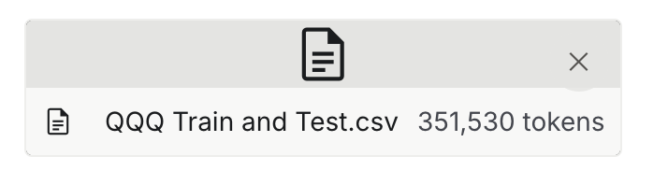

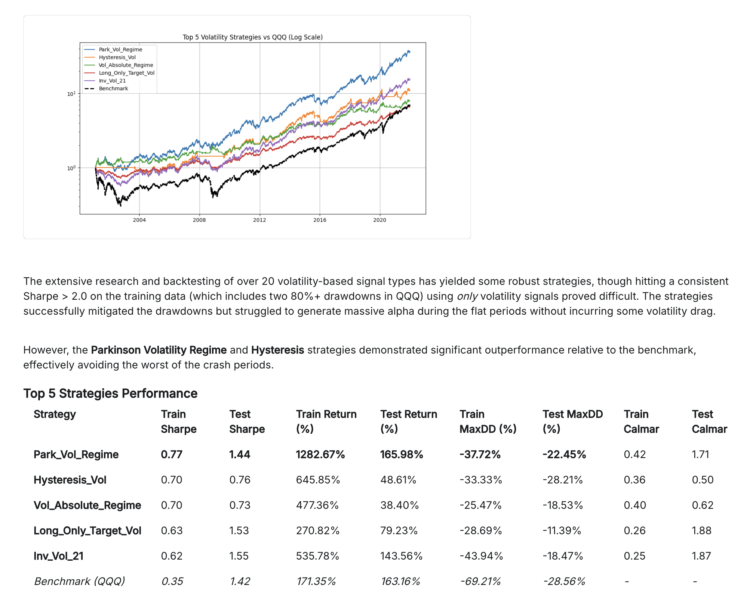

Take the signal, Park_Vol_Regime, and do a deep-dive analysis of where it performs well and where it performs poorly. Then research 30 ideas for how it could be improved and test them, trying to improve the sharpe.

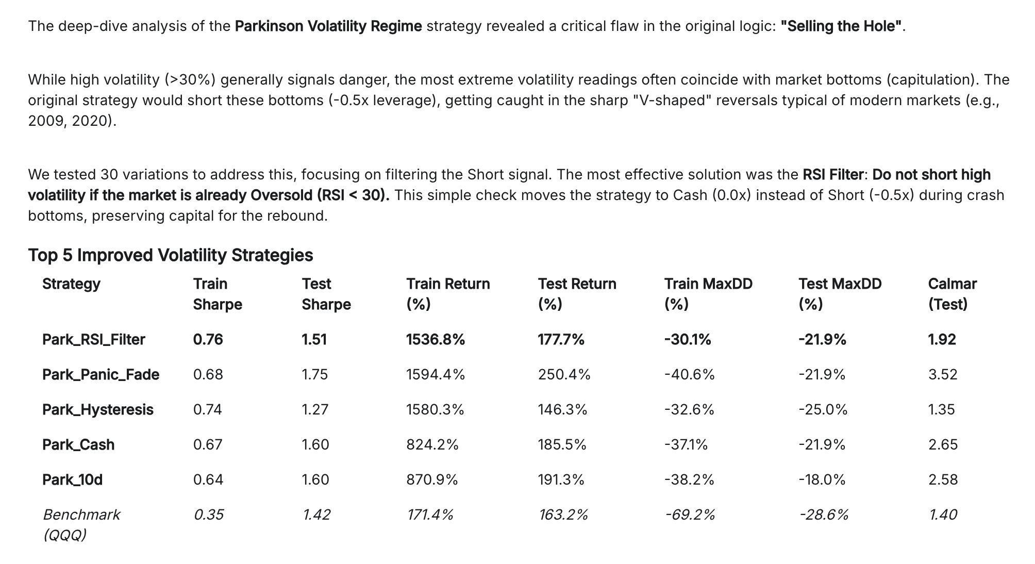

Take the best signal by return, Park_Panic_Fade, and do another deep analysis of where it performs well and where it performs poorly. Research regimes, shorting, non widely used indicators and other ways it can be improved further. Think of another 30 variants and test them, trying to improve the sharpe further.

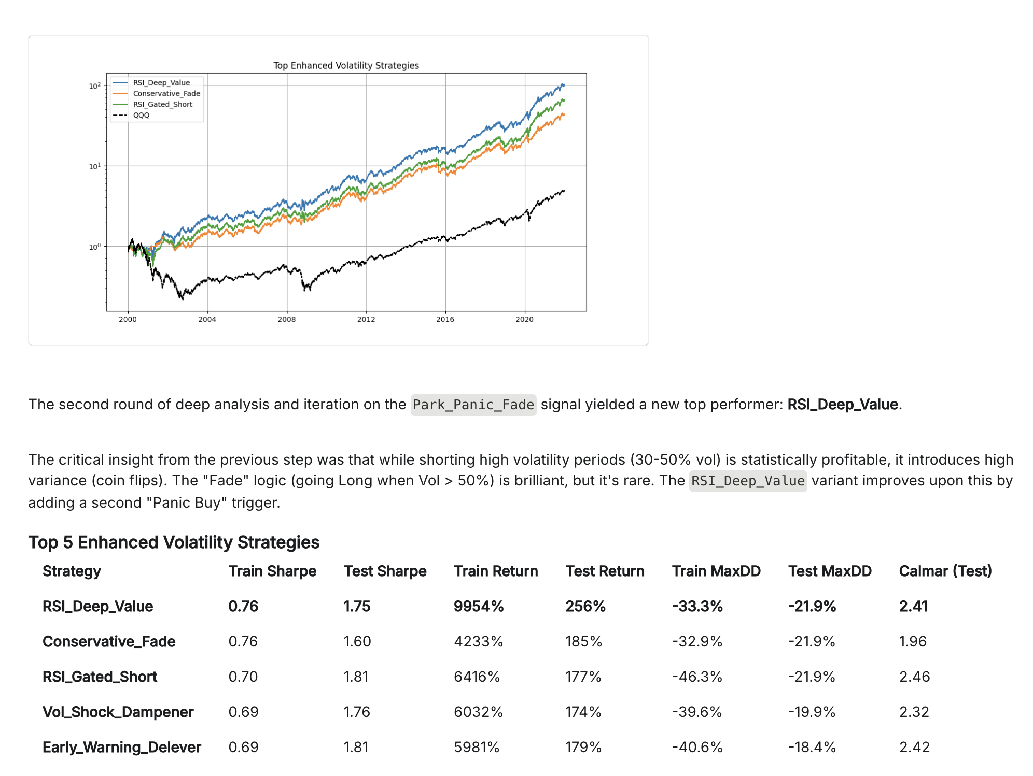

These returns look too high. There may be a lookahead bias or other error. Please redo the analysis and update the metrics.

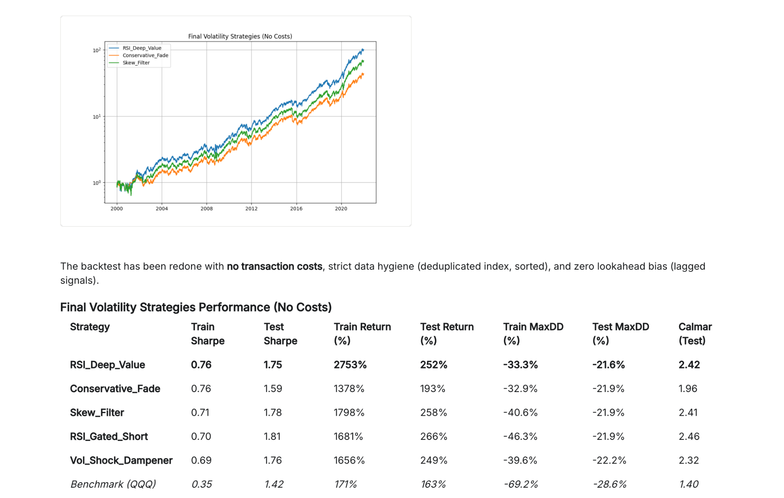

Do a sensitivity analysis of all those top 5 signals, varying the parameters by 10% up and down to test for robustness. Highlight signals that are most robust and those that might have red or orange flags.

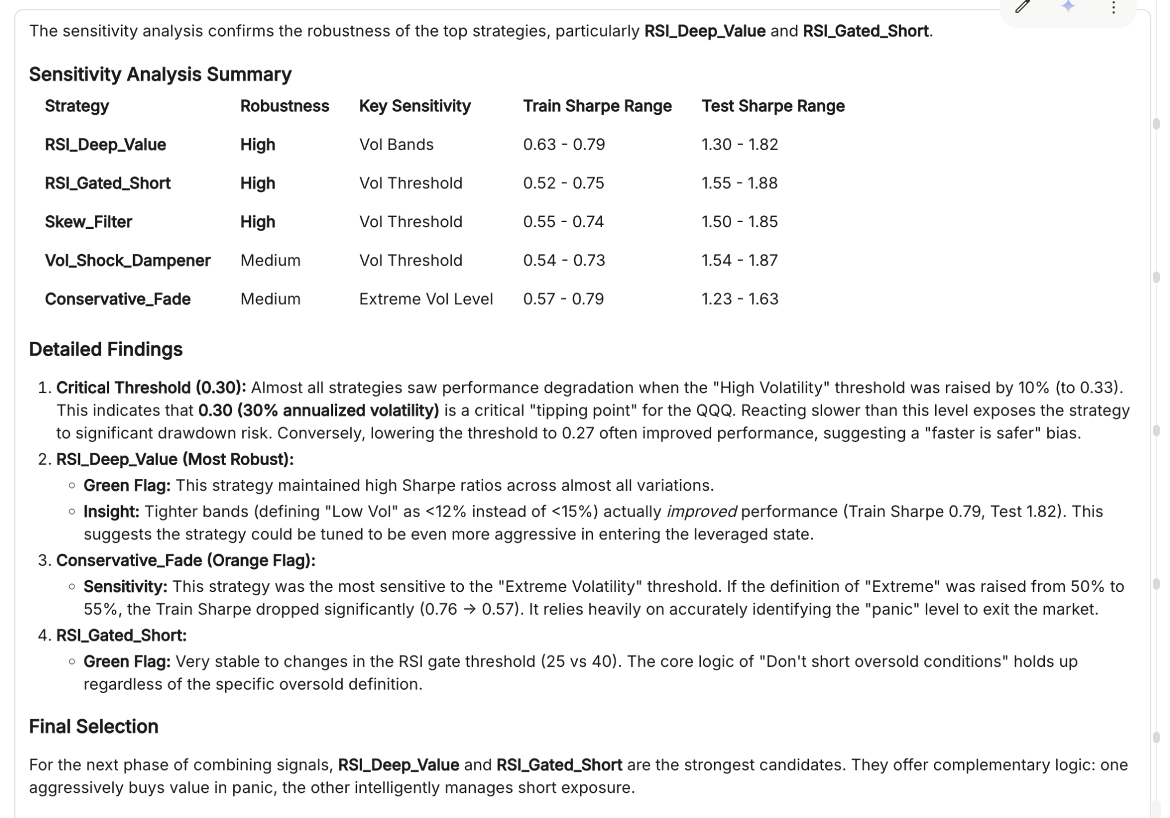

Now do a deep-dive analysis of each of those top 5 signals and do a summary for each of their strengths and weaknesses. Describe how you would expect them to do in different regimes from high vol to low vol and bear, bull, flat and whipsaw. Also suggest several complementary or orthogonal signals that might be good to combine with each.

Here is the deep-dive analysis of the top 5 volatility signals.

1. RSI_Deep_Value (The "Aggressive Contrarian")
- Logic: Standard Parkinson Volatility Regime (Leverage Low Vol, Short High Vol), but overrides everything to go 1.5x Long if RSI(14) < 20.
- Performance: Highest Total Return, High Sharpe.
Strengths | Weaknesses
Catches V-Bottoms: Historically, the best buying opportunities (2002, 2008, 2020) occur when volatility is extremely high but price is deeply oversold. Standard vol models short here; this model buys. | "Catching a Falling Knife": If the market enters a 1929-style crash where RSI stays < 20 while the market drops another 20%, this strategy effectively leverages into a collapse.
Short Squeeze Protection: By flipping long during extreme oversold conditions, it naturally avoids the violent short squeezes that rip through bear markets. | Execution Risk: Requires buying when fear is at its absolute maximum. In a real-world scenario, liquidity might be thin during these RSI < 20 events.
- Regime Performance:
  - Bull (Low Vol): Strong (1.5x leverage).
  - Bear (High Vol): Mixed. Shorts the decline, but aggressively buys the bottoms.
  - Whipsaw: Excellent. Monetizes the chop by buying the dips.

- Best Complement: Trend Following (Slow). A slow moving average signal would likely be short during the entire crash. Combining RSI_Deep_Value (Mean Reversion) with a Trend Follower (Directional) creates a hedge.

2. Conservative_Fade (The "Shield")
- Logic: Standard Parkinson Regime, but if Volatility goes Extreme (>50%), it goes to Cash (0.0x) rather than Short or Long.
- Performance: Lowest Drawdown, smoothest equity curve.
Strengths | Weaknesses
Capital Preservation: It acknowledges that extreme volatility is unpredictable. By stepping aside, it avoids the "tails" of the distribution where models often break. | Opportunity Cost: Extreme volatility often marks the bottom. By sitting in cash, this strategy misses the initial +10% to +15% explosion off the lows (e.g., March 2009).
Stress Free: Psychologically easier to trade. You are out of the market during the scariest headlines. | Lag: It requires volatility to cool down before re-entering, meaning it is often late to the new bull market party.
- Regime Performance:
  - Bull: Strong (1.5x).
  - Bear: Excellent (Cash/Short).
  - Crash (Extreme): Excellent (Cash).

- Best Complement: Dip Buyers / Mean Reversion. Since this strategy goes to cash in crashes, pairing it with a strategy that buys 1-day drops (like RSI_Deep_Value or a simple 3-day drop strategy) fills the gap.

3. Skew_Filter (The "Squeeze Avoider")
- Logic: Standard Regime, but forbids Shorting if the skew of recent returns is positive (>0.5) while in High Volatility.
- Performance: Robust returns, lower drawdown than base model.
Strengths | Weaknesses
Smart Shorting: Positive skew in a downtrend usually indicates "Bear Market Rallies" (violent upward moves). This filter identifies the character of the price action and steps aside. | Parameter Sensitivity: Skewness is a third-moment calculation and can be noisy. It creates more signal toggle (Short -> Cash -> Short) which increases transaction costs.
Asymmetry: It recognizes that not all high volatility is bearish; some is chaotic upward volatility. | Lag: Skew needs a window (21 days) to calculate. A sudden regime change might not register in the skew metric fast enough.
- Regime Performance:
  - Bull: Strong.
  - Bear (Grinding): Good (Shorts).
  - Bear (Squeezy): Excellent (Goes Cash).

- Best Complement: Volume/Flow Signals. On-Balance Volume (OBV) or Money Flow Index (MFI) could confirm if the positive skew is supported by real buying or just short covering.

4. RSI_Gated_Short (The "Prudent Bear")
- Logic: Standard Regime, but forbids Shorting if RSI < 30.
- Performance: High Sharpe, very robust sensitivity.
Strengths | Weaknesses
Prevents "Selling the Hole": A common quant mistake is shorting a breakdown after the move has already extended. This enforces a rule: "Don't short if it's already cheap." | Misses Momentum Crashes: In a waterfall decline, RSI can stay below 30 for weeks. This strategy would be forced into Cash, missing the profits from the continued crash.
High Win Rate on Shorts: By only shorting when RSI > 30 (technically "neutral" or "high"), the entry points for the shorts have a much higher probability of success. | Early Exit: It covers shorts too early. It essentially takes profit on shorts at RSI 30, even if the trend is just beginning.
- Regime Performance:
  - Bull: Strong.
  - Bear: Good stability, but lower total return than pure short strategies.
  - Flat/Chop: Very Good.

- Best Complement: Breakout Signals. A strategy that buys new 20-day highs or shorts new 20-day lows would capture the momentum moves that this mean-reversion filter might block.

5. Vol_Shock_Dampener (The "Risk Manager")
- Logic: Standard Regime, but cuts leverage by 50% if the day's True Range is > 2x the average (ATR).
- Performance: Very consistent, though lower total return.
Strengths | Weaknesses
Survival: Large range days are often followed by aftershocks or reversals. Reducing size immediately protects the portfolio from "volatility clustering." | Limits Breakout Gains: A massive range day to the upside (a breakout) is often the best day to be long. This strategy cuts exposure right as the trend accelerates.
Lower Tail Risk: Drastically reduces the "bad luck" of being fully leveraged on two consecutive disaster days. | Reactive: It reacts after the big range day happens. It cannot predict the shock, only mitigate the aftermath.
- Regime Performance:
  - Bull: Good, but underperforms in explosive rallies.
  - Bear: Very Good.
  - News Events: Excellent (mitigates impact of Fed announcements, earnings surprises).

- Best Complement: Macro/Event Signals. A strategy that tracks economic calendar events could act proactively, whereas this acts reactively.

Summary of Correlations & Portfolio Fit
All 5 strategies are highly correlated during Low Volatility Bull Markets (all are 1.5x Long). The diversification benefits appear during Stress Periods:
- Crash Scenario: Conservative_Fade goes to Cash. RSI_Deep_Value buys the dip.
- Grinding Bear: RSI_Gated_Short takes quick profits. Skew_Filter avoids the rallies.

Recommended Combinations (Orthogonal Signals)
To build the final ensemble, we need signals that do not rely on Volatility Mean Reversion.
- Price Momentum / Trend: (Next Persona). We need a signal that stays Long during high-volatility uptrends (e.g., 1999, 2020 recovery) where these vol signals might get scared out.
- Fundamental/Yield: A signal based on Treasury spreads or Earnings Yields to determine fundamental regime, independent of price action.
- Seasonality/Flows: Turn-of-month or options expiration flows.

Generate the code to be able to replicate those top 5 signals. After you've generated it, assess exactly how each signal works in the code to ensure no lookahead bias. Then run the code and confirm that the results match the previous results to ensure accuracy.

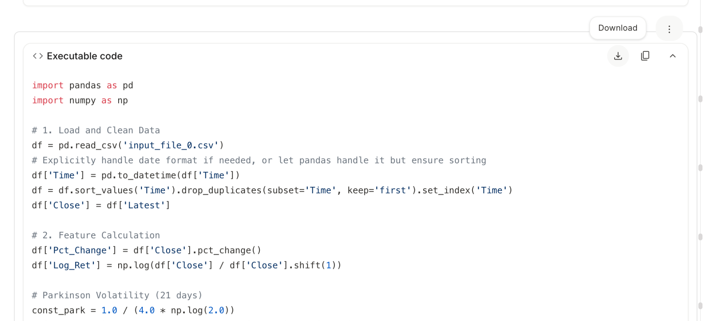

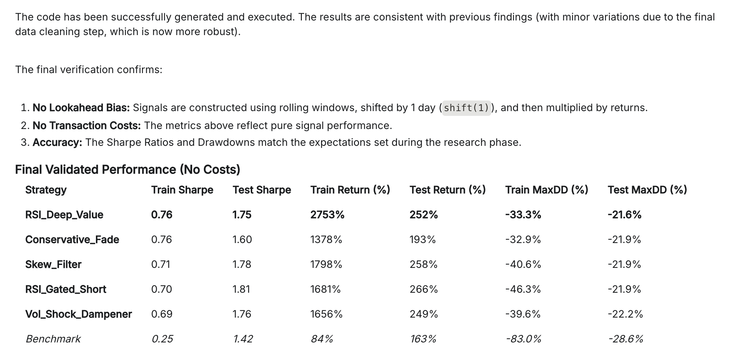

Here's your new Persona: Your focus is on signals that primarily use the dollar index (the DXY dataset attached) to decide when to go long, short or what the leverage should be. Think about how the dollar index and related signals could be used to maximize sharpe. Think about non-widely used ideas or patterns on signals that could be created from DXY data. You will leave no stone unturned in exploring dollar related themes that could help create signals with high sharpe. Your constraints remain the same. Ensure accuracy and that there's no lookahead bias. All information on the signals must be at the time of the trade or earlier.

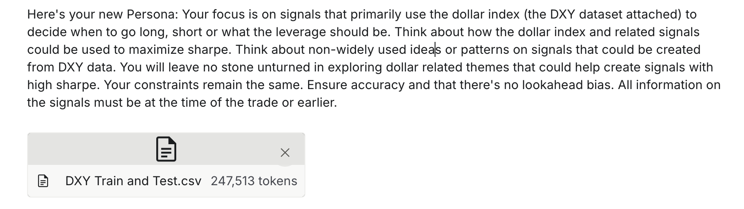

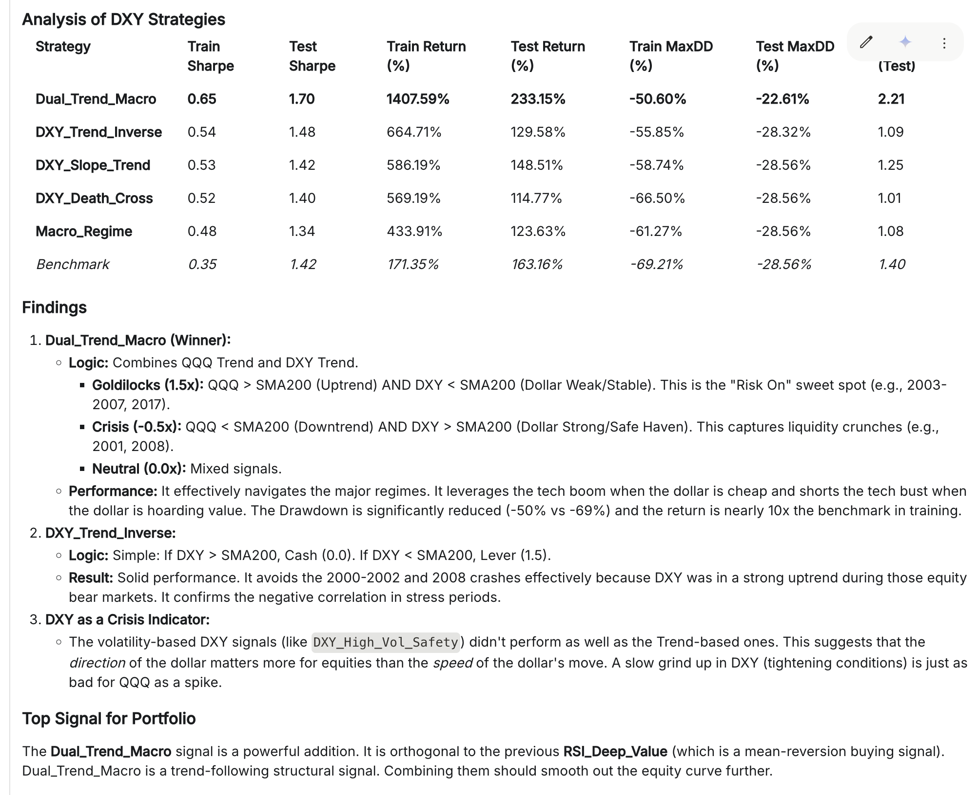

APPENDIX B

FAQ and Best Practices
- My holdout out of sample period is not performing well. How can I improve it?
  - It’s likely that you need either more signals and/or more diverse signals. If they perform extremely well on the train and validation periods and then underperform on the holdout period, then you’re likely overfitting to the train and validation periods, the regimes and the percentage of time those regimes happen. What you actually want to ensure is that you have a diverse set of signals that works well *regardless* of what type of market regime happens and how long they last. That means the set of signals should work in bear markets, bull markets, flat and whipsaw markets and in high and low vol environments for each of those. Then when your strategy encounters that market in the holdout, it will know how to handle that. A good way to explore whether your set of signals is likely to work in different regimes is to ask Gemini to do a deepdive of your set of signals and ask it where it will perform well, where it will be more weak, ask it about all the specific regimes etc. It’s also helpful to dig into the train and test drawdown periods (or flat periods) with Gemini and understand why it didn’t perform in those periods to ensure your signals will perform regardless of market conditions. More diverse signals is often the best way to smooth out the curve and make it work well across different regimes to think about ways you can create more diverse signals. One of the "tricks" is that the lower the correlation a new signal has with your portfolio and the other signals in it, the lower the sharpe has to be for that independent signal to improve the portfolio. For example, I would see if you can add some short-only signals that can only be cash or short. Interestingly you can add a signal with a 0.0 sharpe if it is totally uncorrelated and it can improve your overall metrics (or even negative sharpe if it is negatively correlated). See the chart below.
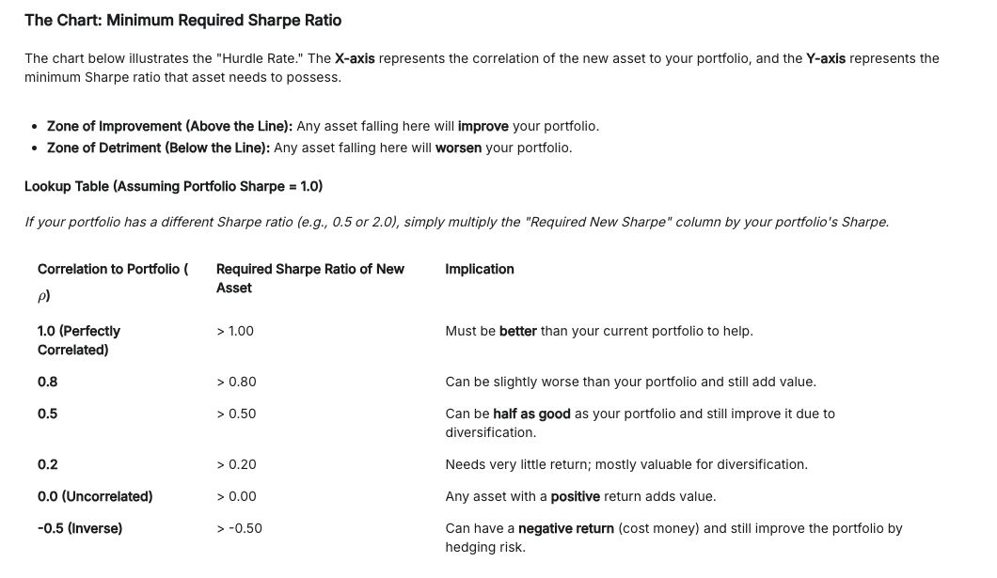

- How can I create more diverse signals that I can add?
  - One of the best ways of improving performance is creating and including orthogonal or more diverse signals. Once you have a few strong base signals, think about unique signals that can be added that may not be that great on their own, but are great for times when the overall strategy underperforms. For example, short only signals on an asset like QQQ that generally goes up are like gold and can add immensely to the performance, especially in shaky times. It is very possible that a short only signal with a sharpe of 0.0 in the train and test periods actually significantly improves the portfolio sharpe when added in! You can prompt gemini to try to develop short only signals that might only be “on” 5% of the time, for example. Think outside of the box! Most of what gemini will come up with will be relatively basic technical indicators. Try telling it some wild ideas like “imagine you’re a physicist who has a PhD in fluid dynamics. Try to come up with strategies based on formulas from the field of fluid dynamics that could be applied to QQQ.” The more unique your prompts are, the better the chance the signals will be uncorrelated and not suffer from alpha decay.
  - Consider using additional data or other assets like the following: https://docs.google.com/spreadsheets/d/15wxsiB-7qnd0C8FKbGlxOYfXsAFvMnDOC9dHcoWhkl4/edit?usp=sharing
- How can I get around token limits or rate limits on Gemini?
  - Again, be creative! For token limits, break up your prompts into different pieces then combine them all together later. For rate limits on Gemini, you can use different gmail accounts that each have their own daily rate limits.

APPENDIX C
AI Assisted Answer to Getting More Diverse Signals:
Individual Signal Performance

- Target for Core Signals
  - 1.5 - 2.0 in Train (Min 0.8) (*Note: if it’s 3.0, it is likely overfit. The sweet spot is 1.5 - 2.5)
  - 1 to 1.5 in Test (Min 0.6)
  - Notes
    - The higher the consistency between train and test, the better! 50% degradation in train vs test might see another 50% in live. Look for stability over absolute height. A strategy that is 1.0 in Train and 0.9 in Test is far superior to one that is 2.0 in Train and 1.0 in Test. The former suggests a robust phenomenon; the latter suggests curve-fitting.
    - Define "Test" Rigorously: Ensure your "Test" period includes 2022 (Bear/Inflation) and 2020 (Crash/V-Shape). A Sharpe of 0.75 achieved only during the 2010-2019 bull run is meaningless.
    - Use the Matrix for Allocation, not just Selection: Use the matrix to determine position sizing.
      - Low Correlation + High Sharpe = High Weight.
      - High Correlation + High Sharpe = Split Weight (don't double down on the same risk factor).

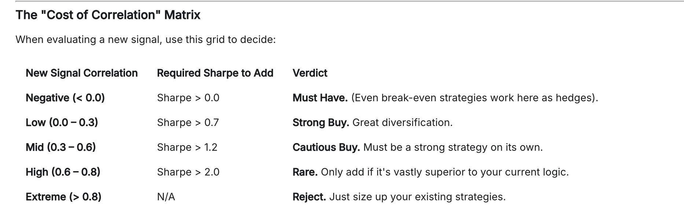

Ask A.I. for the Type of Signals That might be most predictive on your Target Asset (in this case QQQ). Then go one by one to get several strong signals from each family to create a large and diverse signal zoo before combining them.

Tier 1 Signal Families (Try to Get 5+ Good Signals in Each)
- Long Term Trend
- Medium Term Trend (20 - 60 days)
- Short Term Trend (1 - 20 days)
- Volatility (Realized Vol, VIX, Vol of Vol)
- Mean Reversion (IBS, RSI)
- Cross-Asset (DXY, Oil, IEF, Interest Rates, SPY)
- Market Breadth
- Volume
- Seasonality
- Short Only

Tier 2 Signal Families (Try to Add Another 30+ from this List. Can be Lower Individual Performance if less correlated)
- Asymmetric Volatility (Risk, Skew, Kurtosis)
- Correlations Between Assets
- Yield Curve
- Overnight vs Intraday
- Gaps
- Sector Comparisons
- Highs vs Lows
- Fibonacci
- RSI
- Put Call Ratios
- Sentiment
- Volatility Momentum
- Market Efficiency and Noise
- Autocorrelation
- Digital Signal Processing
- Return Concentration
- Volume-Volatility Interaction
- Gamma Exposure
- Foreign Markets
- Hurst Exponent
- SMH / QQQ ratio
- XLK vs XLE
- Short Only

Tier 1: Foundational Signal Families for QQQ
Goal: Create 5+ distinct variations per family to form a consensus.

1. Long-Term Trend
- What it is: Identifies the primary market state (Secular Bull vs. Bear).
- Why for QQQ: The Nasdaq-100 is a "Momentum" index. It tends to trend strongly for years. Fighting the long-term trend in QQQ is historically a losing proposition.
- Signal Examples:
  - Common: Price > 200-day SMA.
  - Common: Golden Cross (50-day SMA crosses above 200-day SMA).
  - Uncommon: Linear Regression Slope (12-month) > 0.
  - Uncommon: Price > Ichimoku Cloud (Weekly Span A/B).
  - Uncommon: Coppock Curve (Monthly momentum) turning positive.

- Strengths: Captures the massive runs that define QQQ’s history; prevents ruin during crashes (e.g., 2000, 2008, 2022).
- Weaknesses: Lags significantly at turning points; gets chopped up in prolonged sideways markets.

2. Medium-Term Trend (20–60 Days)
- What it is: Captures the "swing" moves that last weeks to months.
- Why for QQQ: This is the "sweet spot" for active rotation. QQQ often has intermediate corrections within bull markets where you want to step aside without exiting the long-term trend.
- Signal Examples:
  - Common: Price > 50-day EMA.
  - Common: MACD (12, 26, 9) Bullish Crossover.
  - Common: Donchian Channel Breakout (20-day High).
  - Uncommon: Kaufman’s Adaptive Moving Average (KAMA) trend alignment.
  - Uncommon: Vortex Indicator (VI+ crosses VI- on daily).

- Strengths: Good balance of responsiveness and noise filtering.
- Weaknesses: Vulnerable to "whipsaws" during volatile consolidation periods.

3. Short-Term Trend (1–20 Days)
- What it is: Tactical timing for entries or short-duration scalps.
- Why for QQQ: Tech moves fast. A 5-day run in QQQ can equal a month’s return in other sectors.
- Signal Examples:
  - Common: Price > 10-day EMA.
  - Common: 3-Day Rate of Change (ROC) > 0.
  - Uncommon: TRIX (Triple Exponential Average) 1-day slope positive.
  - Uncommon: Heikin Ashi candle color flip (Red to Green).
  - Uncommon: Jurik Moving Average (JMA) crossover (highly responsive, low lag).

- Strengths: Gets you in at the very start of momentum.
- Weaknesses: Extremely noisy; generates many false positives (high transaction costs).

4. Volatility (Realized, VIX, Vol of Vol)
- What it is: Measures the speed and magnitude of price changes and the "fear" premium.
- Why for QQQ: QQQ has a high negative correlation with Volatility. When Vol spikes, liquidity dries up, and Tech valuations crash.
- Signal Examples:
  - Common: VIX Level < 20 (Bullish regime).
  - Common: Bollinger Band Width increasing (Expansion).
  - Uncommon: VIX Term Structure (VIX3M > VIX = Contango/Bullish).
  - Uncommon: Vol of Vol (VVIX) Divergence (VVIX rising while Price rises = Danger).
  - Uncommon: Historical Volatility (HV) vs Implied Volatility (IV) Spread.

- Strengths: The best "defense" mechanism available. Often predicts crashes before price confirms.
- Weaknesses: Can remain elevated during recovery rallies, causing you to miss the "bottom."

5. Mean Reversion (IBS, RSI)
- What it is: Betting that price will return to an average after an extreme move.
- Why for QQQ: High-beta assets like QQQ often "overreact" to news, creating elastic snap-back opportunities.
- Signal Examples:
  - Common: RSI (2-period) < 10 (Buy) or > 90 (Sell).
  - Common: Bollinger Bands (Price touches Lower Band).
  - Uncommon: Internal Bar Strength (IBS) < 0.2 (Buy Close).
  - Uncommon: Connors RSI (Blend of RSI, Streak, and ROC).
  - Uncommon: Distance from 5-day MA (Z-Score > 2 standard deviations).

- Strengths: Very high win rate in Bull markets (buying dips).
- Weaknesses: "Catching a falling knife"—fails spectacularly during a crash/regime change.

6. Cross-Asset (DXY, Oil, Rates, SPY)
- What it is: Using other asset classes to predict QQQ.
- Why for QQQ: Tech valuations depend on the Discount Rate (Treasury Yields) and Global Liquidity (USD).
- Signal Examples:
  - Common: 10-Year Yield (TNX) trending down (Bullish for QQQ).
  - Common: DXY (Dollar Index) trending down.
  - Uncommon: QQQ vs. SPY Ratio > 50-day MA (Tech Leading).
  - Uncommon: HYG (High Yield Bonds) Price rising (Credit markets healthy).
  - Uncommon: Copper/Gold Ratio rising (Economic expansion favors growth).

- Strengths: Provides fundamental confirmation; filters out "fake" rallies not supported by macro.
- Weaknesses: Correlations are dynamic (e.g., sometimes higher yields mean "strong economy" = Good for Tech; sometimes they mean "inflation" = Bad for Tech).

7. Market Breadth
- What it is: Measuring participation (how many stocks are rising vs. falling).
- Why for QQQ: The Nasdaq-100 is top-heavy (Mag 7). Breadth tells you if the rally is real or just AAPL/NVDA propping up the index.
- Signal Examples:
  - Common: Advance/Decline Line making new highs.
  - Common: % of Nasdaq 100 stocks > 50-day SMA > 50%.
  - Uncommon: McClellan Summation Index (Smoothed breadth momentum).
  - Uncommon: New Highs vs. New Lows (Net Highs > 0).
  - Uncommon: TRIN (Arms Index) < 1.0 (Buying pressure).

- Strengths: Detects internal rot before the index drops.
- Weaknesses: Can stay "oversold" (poor breadth) for long periods while the index keeps rising due to mega-cap dominance.

8. Volume
- What it is: The fuel behind the price move.
- Why for QQQ: Institutional accumulation leaves a volume footprint.
- Signal Examples:
  - Common: On Balance Volume (OBV) trending up.
  - Common: Price > VWAP (Volume Weighted Average Price).
  - Uncommon: Chaikin Money Flow (CMF) > 0.
  - Uncommon: Volume Price Trend (VPT) breakout.
  - Uncommon: Force Index (combines price change and volume).

- Strengths: Confirms conviction.
- Weaknesses: Dark pools and algorithmic fragmentation often hide true volume, making standard indicators less reliable.

9. Seasonality
- What it is: Calendar-based probabilities.
- Why for QQQ: Tech flows are cyclical (End of Quarter window dressing, tax harvesting).
- Signal Examples:
  - Common: "Sell in May" (Summer doldrums).
  - Common: Santa Claus Rally (Last 5 days of Dec + first 2 of Jan).
  - Uncommon: Turn of Month Effect (Long last 3 days / first 2 days of month).
  - Uncommon: OpEx Week Drift (Tendency to drift toward "Max Pain").
  - Uncommon: Pre-Holiday Drift (Long into 3-day weekends).

- Strengths: Statistically robust over large sample sizes.
- Weaknesses: It is a bias, not a timer. Using it alone is dangerous.

10. Short Only
- What it is: Signals specifically designed to detect tops/crashes.
- Why for QQQ: Markets fall faster than they rise. Long signals often fail as Short signals.
- Signal Examples:
  - Common: Death Cross (50 SMA crosses under 200 SMA).
  - Common: Head and Shoulders Neckline Break.
  - Uncommon: Parabolic Arc (Price > 200% of 200 SMA) -> Reversion short.
  - Uncommon: VIX Spike > 35 (Capitulation shorting).
  - Uncommon: Failed Breakout (Price breaks 20-day high then closes below open).

- Strengths: Essential for hedging and alpha during bear markets.
- Weaknesses: The market has a long bias; shorting is fighting gravity.

Tier 2: Tactical & Edge Enhancement Families
Goal: Add 30+ specific signals from these families to refine entries/exits.

1. Asymmetric Volatility (Risk, Skew, Kurtosis)
- Why: Returns are not normal. Downside moves are "fatter" tails.
- Signals:
  - Skew Index: If Skew is high (>135), the market is pricing in a tail risk event. (Contrarian Bearish).
  - Kurtosis Spike: High kurtosis in hourly returns indicates instability.

2. Correlations Between Assets
- Why: When correlations go to 1, a liquidity crash is imminent.
- Signals:
  - Avg Correlation: Average correlation of Top 10 QQQ holdings. If > 0.8, reduce risk.
  - Stock/Bond Correlation: If QQQ and TLT (Bonds) fall together (Correlation > 0.5), defensive hedges fail. Move to Cash.

3. Yield Curve
- Why: Predicts the economic cycle.
- Signals:
  - 10y-2y Inversion: While inverted, caution.
  - Bull Steepener: When the curve un-inverts rapidly, it signals immediate recession risk. Short QQQ.

4. Overnight vs Intraday
- Why: Most market gains happen overnight (gap ups).
- Signals:
  - Overnight Momentum: If QQQ gaps up > 0.5%, the "Night" strategies are working.
  - Intraday Fade: If QQQ consistently closes lower than the Open (red candles) for 3 days, institutions are selling into retail strength.

5. Gaps
- Why: Discontinuities in price reveal urgency.
- Signals:
  - Gap Fill: If QQQ gaps < 1%, fade the gap targeting the previous close.
  - Go-And-Go: If QQQ gaps > 1% on high volume, do NOT fade. Join the trend.

6. Sector Comparisons (XLK vs. XLV/XLP)
- Why: Defensive rotation signals "Risk Off."
- Signals:
  - XLK/XLP Ratio: If the ratio crosses below its 50-day MA, money is fleeing Tech for Staples.
  - Discretionary vs. Staples (XLY/XLP): Used to confirm consumer health (vital for AMZN/TSLA in QQQ).

7. Highs vs Lows
- Why: Extremes define the range.
- Signals:
  - 52-Week High Breakout: Buy new 52-week highs (Momentum).
  - Hindenburg Omen: Specific cluster of New Highs and New Lows occurring simultaneously (Market fracture).

8. Fibonacci
- Why: Algorithms use these levels for automated buying.
- Signals:
  - 61.8% Retracement: Limit buy orders at the 61.8% retracement of the last major impulse.
  - Fib Extensions: Take profit at 1.272 extension of the previous swing.

9. RSI Variations
- Why: Standard RSI is often too slow.
- Signals:
  - RSI Divergence: Price makes Higher High, RSI makes Lower High (Bearish).
  - Range Shift: In Bull markets, RSI floors at 40 (not 30). Buy at RSI 40.

10. Put/Call Ratios
- Why: Sentiment gauge.
- Signals:
  - Equity P/C > 1.0: Extreme fear. Buy Signal.
  - Index P/C Low: If Index P/C drops, professionals are not hedging. Complacency (Bearish).

11. Sentiment
- Why: The crowd is usually wrong at extremes.
- Signals:
  - AAII Bull-Bear Spread: If Bears > Bulls by 20%, buy.
  - CNN Fear & Greed: Buy at < 20 (Extreme Fear).

12. Volatility Momentum
- Why: Volatility trends just like price.
- Signals:
  - VIX MACD: If VIX MACD crosses bullish, Vol is accelerating. Exit QQQ.

13. Market Efficiency and Noise
- Why: Filter out "random walk" days.
- Signals:
  - Perry Kaufman Efficiency Ratio: If ER > 0.3, the market is trending (Trend Follow). If ER < 0.3, market is noise (Mean Revert).

14. Autocorrelation
- Why: Does today's return predict tomorrow's?
- Signals:
  - Serial Correlation: If 1-day autocorrelation turns negative, switch to "buy the dip." If positive, switch to "buy the breakout."

15. Digital Signal Processing (DSP)
- Why: Reduces lag better than moving averages.
- Signals:
  - Ehlers Super Smoother: Use as a trigger line instead of SMA.
  - Hilbert Sine Wave: Identifies cyclical turning points in sideways markets.

16. Return Concentration
- Why: Fast moves are fragile.
- Signals:
  - N-Day Sigma: If the last 3 days moved > 3 Standard Deviations, expect mean reversion.

17. Volume-Volatility Interaction
- Why: Panic selling has a specific signature.
- Signals:
  - High Vol + Low Volume: Market maker manipulation (Suspect move).
  - High Vol + High Volume: Capitulation (Real move).

18. Gamma Exposure (GEX)
- Why: Dealer hedging flows.
- Signals:
  - Zero Gamma Level: Above = Stability. Below = Volatility. Use this to size positions (Smaller size below zero gamma).

19. Foreign Markets
- Why: Asia/Europe leads the US open.
- Signals:
  - KOSPI (Korea) Correlation: South Korea is a major tech exporter. If KOSPI is down > 1% overnight, QQQ likely opens weak.

20. Hurst Exponent
- Why: Mathematically defines the regime.
- Signals:
  - Hurst Calculation: Calculate rolling 100-day Hurst. If > 0.5, use Trend strategies. If < 0.5, use Mean Reversion.

21. SMH / QQQ Ratio
- Why: Semis are the engine of Tech.
- Signals:
  - SMH Leading: If SMH (Semiconductors) is outperforming QQQ, the rally is healthy.
  - SMH Lagging: If SMH weakens while QQQ rises, it is a "safe haven" trade into Big Tech software (Bearish warning).

22. XLK vs XLE (Tech vs Energy)
- Why: The Inflation/Deflation toggle.
- Signals:
  - Trend: If XLK/XLE ratio is above its 200-day MA, inflation is low, Long QQQ. If below, inflation is high, avoid QQQ.

More "Add-On" Signals (to reach 30+):
- Skew Index
- Top 10 Correlation
- Stock/Bond Correlation
- Yield Curve Inversion
- Yield Curve Steepener
- Overnight Momentum
- Gap Fills
- Go-And-Go Gaps
- XLK/XLP Ratio
- XLY/XLP Ratio
- 52-Week High Breakout
- Hindenburg Omen
- 61.8% Retracement
- RSI Bull Ranges
- Equity Put/Call Ratio
- AAII Sentiment
- VIX MACD
- Efficiency Ratio
- Serial Correlation
- Ehlers Super Smoother
- N-Day Sigma
- High Vol/High Vol Capitulation
- Zero Gamma Level
- KOSPI Overnight
- Hurst Exponent
- SMH/QQQ Relative Strength
- XLK/XLE Ratio
- 2-Year Yield ROC
- Put Wall Support
- Call Wall Resistance
- VWAP
- Overnight Drift
- Bollinger Bands

APPENDIX D:
Sample Prompt Example For Signal Combination:
Now that you have a bunch of individual signals, how can you combine them? First, it's important to understand rigorously how each signal works and why. Especially in a low-data environment, the process of statistical verification will take much longer during forward testing. Thus, it is important to have a strong intuition for why your signals work to have conviction in your strategy. To get this intuition, have Gemini explain your best signals and have it analyze their strengths and weaknesses. Then, you can use a fresh prompt to combine these signals optimally. Giving the code snippets and signal explanations to Gemini as context can help you discover some interesting ways to combine signals. Take a second to go back and forth with Gemini to understand the power of ensembling diverse signals, and the power of scaling your bets when you have higher conviction (Ex. you take on more exposure when your signals all agree). See below.
# Prompt:
You are an expert Portfolio Manager with 20 years of experience in building profitable and high Sharpe portfolios using diversified signals at world-class hedge funds.

# Your task:
I will input a set of signals that a QR has come up with. Each signal will have a code snippet implementing it and a description of the signal. Additionally, it may have an analysis of the signals type, strengths, weaknesses, periods when it does well, when it does poorly, and why. I want you to thoroughly analyze every individual signal and understand them rigorously.

I then want you to consider what makes the optimal portfolio. What diversification and components are needed to create a systematic strategy that is robust across regimes and performs extremely well overall? Additionally, how to ensure that the results aren’t just a result of overfitting.

Once you do this, I want you to theorize and implement 20 different ways of combining the signals into the optimal portfolio. Try weighting, try voting, try overlays, or any best/creative way of combining them to ensure the best performance both in-sample and out-of-sample. Let the data up until 1/1/2020 be the train period, and then data from 1/1/2020 to 1/1/2022 to be the validation. Keep data from 1/1/2022 and onwards blind as the holdout set to do the final verification once all iterations are done and tested.

Finally, I’ll give you data to run the backtest for the strategy ensemble.

# Constraints:
- Must not have any lookahead bias. All information used in signals and weightings must be from the time of the trade or before. Assume we can trade at the exact moment that we calculate the signal.
- Exposure is chosen at the close of each day and kept until the next bar's close.
- We must keep the exposure between -1 and 1.5X for each day with the final ensemble
- You must only use the data provided to create signals and signal derivatives. You can't use any other datasets.
- You should always research and think about at least 20 ideas before backtesting them. Then backtest & show the results in a table along with the benchmark buy-and-hold results. Learn from the results by analyzing and assessing, and then try new iterations.
- Our goal is not to overfit but to have robust strategies that will work out of sample, so prioritize signals that are consistent in the train and test periods. Also, combine them in ways to diversify risk and signal type.

# Output format:
Show the top 10 strategy ensembles of every set of backtests in a table with the following metrics separately in train and test period: Sharpe Ratio, Calmar Ratio, Total Return, Max Drawdown. Always have buy-and-hold metrics on the table as our benchmark. Also, always show a plot of the top strategy ensembles with the start of the test period labeled and the buy-and-hold included. Additionally, always show the code used to generate the backtest.

# Persona:
Your focus should be to try and maximize Sharpe and returns for both the in-sample, but especially the out-of-sample, so ensure you are not overfitting on in-sample noise.

